National Real-Time Payments System
Comprehensive Technical & Business Architecture Report
Prepared by: Vinutha Gowde

Contents
1. Executive Summary 3
2. Business Objectives 3
3. System Scale and Requirements 4
4. Architecture Overview 4
5. Deployment Architecture 5
6. Core System Capabilities 6
7. Functional Requirements 6
8. Non-Functional Requirements 7
9. Systems & Subsystems 7
10. Information Exchange 7
11. Failure Handling and Mitigation 9
12. System Behavior Under Load 11
13. Traceability Matrix Requirements 12
14. Cost-Effective Architecture Decisions 12
15. Security Considerations 12
16. Global Benchmarking & Differentiators 13
17. ROI & Impact 14
18. Conclusion 14

1. Executive Summary
The National Real-Time Payments System (NRTP) is a mission-critical national digital infrastructure designed to enable instant peer-to-peer (P2P) and peer-to-merchant (P2M) transactions at scale. Supporting over 150 million registered users and 40 million daily active users, the platform must sustain peak loads exceeding 50,000 transactions per second (TPS) while maintaining transaction latency below two seconds and availability of 99.999%.
Given the financial criticality of the system, the architecture emphasizes:
- Strong consistency for financial records
- Zero data loss
- Real-time fraud detection without performance degradation
- High availability with no single point of failure
- Regulatory compliance (PCI DSS, ISO 27001, national banking regulations)
- Scalability to handle 10x national event spikes
- Future international interoperability
This document outlines the required systems, information flows, failure analysis, mitigation strategies, contingency planning, trade-offs, and global benchmarking.

2. Business Objectives
- Replace cash and delayed bank transfers
The system provides a digital alternative to traditional cash payments and slow inter‑bank transfers, enabling instant settlement and faster economic activity.
- Enable real‑time P2P and P2M payments
Individuals can transfer money instantly to other individuals or merchants using mobile apps, QR codes or POS systems.
- Strengthen financial inclusion
By supporting mobile‑first payments and simple onboarding processes, the system allows unbanked or underbanked users to participate in digital finance.
- Improve transparency and traceability
Digital payment records improve auditability and enable regulators to track financial flows effectively.
- Prepare infrastructure for cross‑border interoperability
The architecture allows future integration with international payment networks and foreign banking systems.

3. System Scale and Requirements
Metric | Value
Registered Users | 150 million
Daily Active Users | 40 million
Peak Concurrent Users | 5 million
Transactions Per Second | 50,000+
Availability | 99.999%
Recovery Objectives | RPO = 0, RTO < 5 minutes

4. Architecture Overview
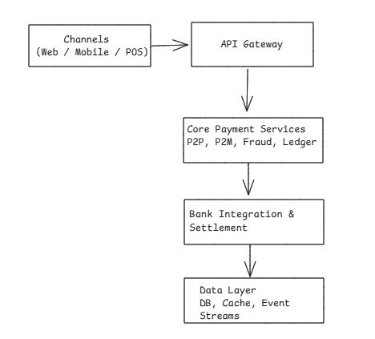
Figure 1: Logical Architecture of the National Real-Time Payments System
The logical architecture separates the system into multiple layers including user channels, API gateway, core payment services, banking integrations, and the data layer. This layered approach ensures scalability, maintainability, and clear separation of responsibilities across system components.
- Channel Layer: Mobile apps, web clients, and merchant POS systems provide user access.
- API Gateway: A secure, centralized entry point for all client requests.
- Core Payment Services: Orchestrates transactions, manages the ledger, performs fraud detection, and supports P2P/P2M flows.
- Bank Integration & Settlement: Ensures connectivity with banking systems, inter-bank settlement, and reconciliation.
- Data Layer: Comprises distributed databases, caches, and event streaming platforms for durability and performance.
- Infrastructure Layer: Active-active multi-region deployment with AKS clusters, load balancers, CDN, and monitoring dashboards ensures resilience and scalability. Cross-cutting concerns such as security, compliance, and observability apply across all layers. The design guarantees strong consistency, zero data loss, and future readiness for cross-border interoperability.

5. Deployment Architecture
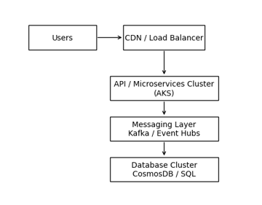
Figure 2: Deployment Architecture
The deployment architecture illustrates how system components are distributed across infrastructure layers. Traffic flows through CDN and load balancers before reaching API servers running microservices in container clusters. Messaging platforms manage asynchronous communication while distributed database clusters provide high availability and durability.

6. Core System Capabilities
- Instant P2P Transfers
Users can send funds instantly between accounts with real‑time confirmation.
- Instant P2M Payments
Merchants receive immediate payment confirmation through QR or POS transactions.
- QR‑based payments
Standardized QR codes simplify merchant acceptance and enable offline-friendly payments.
- Automated settlement
Settlement engines reconcile transactions between participating banks.
- Fraud detection
Machine learning and rule‑based checks analyse transaction patterns in milliseconds.
- Regulatory reporting
All transaction data is captured in audit logs to support regulatory oversight.

7. Functional Requirements
- Instant P2P and P2M transfers
- QR-based merchant payments
- Real-time fraud detection
- Automated inter-bank settlement
- Immutable audit logging
- Merchant dashboards & reporting
- Dispute resolution & chargebacks

8. Non-Functional Requirements
Category | Requirement | Design Response
Performance | 50K+ TPS | Horizontal scaling, caching
Availability | 99.999% | Active-active deployment
Reliability | Zero data loss | Synchronous replication
Latency |  | Optimized orchestration
Security | PCI DSS, ISO 27001 | Encryption, access control

9. Systems & Subsystems
- Core Payment Engine
- Bank Integration Gateway
- Merchant Services
- Fraud Detection & Risk Scoring
- Regulatory Reporting
- Infrastructure: AKS, Redis, Kafka, Cosmos DB

10. Information Exchange
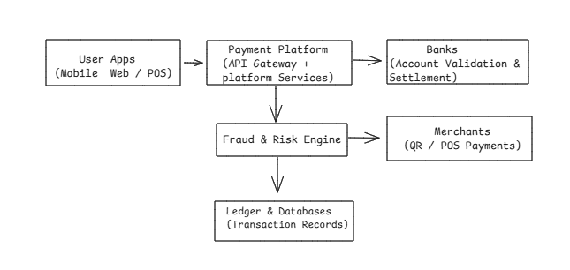
Figure 3: Information Flow Between System Components
Components Shown in the Diagram
- User Applications
- Mobile apps
- Web applications
- Merchant POS systems
These initiate payment requests and receive confirmations.
- Payment Platform
- API Gateway
- Payment orchestration services
- Transaction ledger
Acts as the core processing engine.
- Banks
- Account validation
- Debit / credit processing
- Settlement confirmation
Ensures funds movement between institutions.
- Merchants
- Receive payment confirmations
- Generate daily settlement reports.
- Internal Systems
- Fraud detection engine
- Risk scoring
- Ledger database
- Analytics & monitoring systems.

Flow | Data | Frequency | Speed | Volume
User ↔ Platform | KYC, payment instructions | High |  | Millions/day
Platform ↔ Banks | Debit/credit, settlement | High |  | Thousands/sec
Platform ↔ Merchants | Confirmations, reports | Medium | Daily | GBs/day
Internal | Fraud scoring, ledger updates | Continuous | ms-level | High-volume

11. Failure Handling and Mitigation
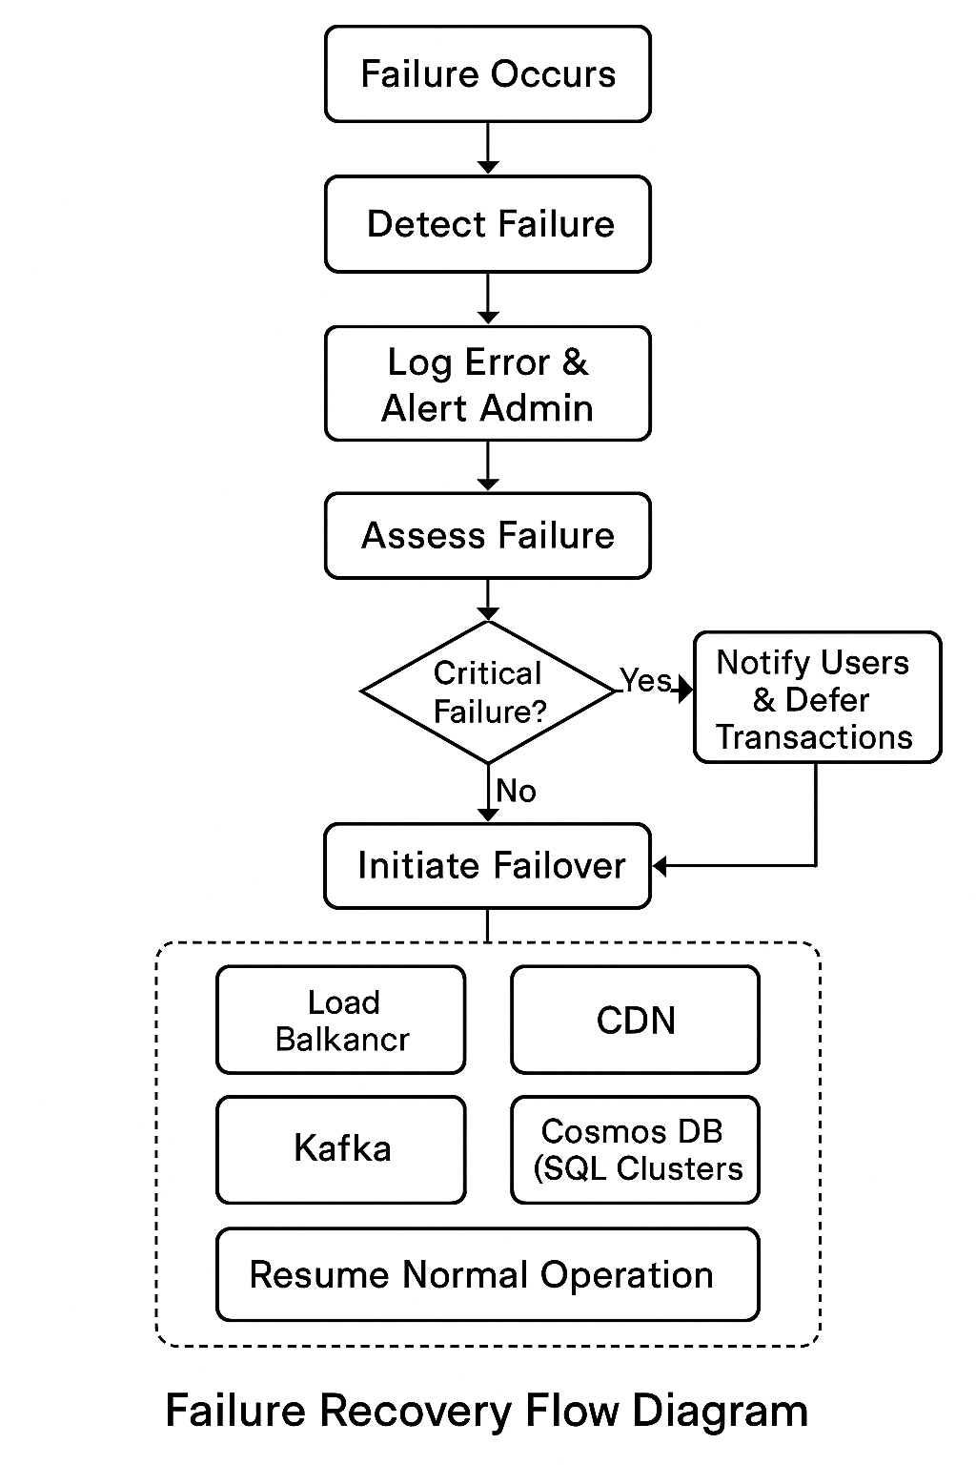

Figure 4: Failure Recovery Flow Diagram

Component | Failure | Mitigation
Payment Engine | Overload | Auto-scaling, load shedding
Bank API | Downtime | Circuit breakers, deferred settlement
Database | Cluster failure | Replication, failover
Fraud System | Delay | Graceful degradation
External Dependencies | Outage | Backup routing, manual reconciliation

- Database failures
Replication and distributed clusters ensure availability if a node fails.
- Bank API downtime
Circuit breaker patterns prevent cascading failures and reroute requests.
- Traffic spikes
Auto‑scaling infrastructure dynamically provisions new compute resources.
- External dependency failures
Fallback processes allow temporary queuing of transactions. 4. Functional Requirements
- Instant P2P and P2M transfers
- QR-based merchant payments
- Real-time fraud detection
- Automated inter-bank settlement
- Immutable audit logging
- Merchant dashboards and reporting
Dispute resolution and chargebacks

12. System Behavior Under Load
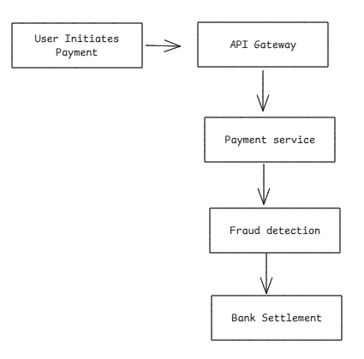
Figure 5: Payment Processing Flow
When a user initiates a payment, the request is routed through the API Gateway to the payment service. Fraud detection checks are performed before the transaction is sent to the bank integration layer for settlement. Once confirmation is received, the ledger is updated and the user receives a transaction status notification.
Normal Daily Load
- Full real-time fraud checks
- Synchronous bank calls
- Standard quorum writes
- Minimal queuing
Peak National Events (10x Load)
- Aggressive auto-scaling
- Increased caching of merchant & account metadata
- Adaptive fraud thresholds
- Asynchronous processing for reporting & analytics
- Load shedding for low-priority traffic
- Pre-warming infrastructure ahead of expected spikes

13. Traceability Matrix Requirements

Business Objective | Functional Requirement | Non-Functional Requirement | System Component
Replace cash & delayed transfers | Instant P2P & P2M payments | Latency <2s | Payment Engine, Bank Integration
Enable real-time payments | QR-based merchant payments | Scalability to 50K TPS | API Gateway, Merchant Services
Financial inclusion | Inter-bank settlement | 99.999% availability | Settlement Engine
Regulatory transparency | Audit logs | HSM-backed encryption | Data Layer

14. Cost-Effective Architecture Decisions
- Serverless for bursty workloads
- Redis + CDN for caching
- Kafka/Event Hubs for async tasks
- Multi-tier storage
- Auto-scaling clusters
- Spot/reserved instances

15. Security Considerations
- DDoS protection, WAF, segmentation
- TLS 1.3, AES-256, PCI DSS compliance
- MFA, RBAC, session management
- OAuth 2.0, rate limiting
- Real-time alerts, audit logs
- GDPR/CCPA workflows

16. Global Benchmarking & Differentiators
Global Reference – India UPI
India’s Unified Payments Interface (UPI) is one of the most successful national real-time payment systems globally. It supports high transaction volumes, seamless bank interoperability, and instant peer-to-peer (P2P) and peer-to-merchant (P2M) payments.
Key characteristics of UPI include:
- Instant bank-to-bank transfers
- QR-based merchant payments
- Strong interoperability across banks and fintech providers
- High scalability during peak transaction periods
- Centralized settlement and reconciliation framework
UPI demonstrates that a well-architected real-time payment system can scale nationally while maintaining reliability and security.
Awareness of Other Global Implementations
Other countries have implemented similar real-time payment infrastructures, such as:
- UK Faster Payments
- Brazil PIX
- US FedNow
These systems also provide instant domestic payments with varying settlement models, regulatory frameworks, and integration mechanisms. While implementation approaches differ, the common objectives are high availability, real-time processing, and financial interoperability.
Unique Differentiators of the Proposed Architecture
Compared to existing global systems, the proposed architecture introduces the following enhancements:
- Active-active multi-region deployment to achieve 99.999% availability
- Intelligent bank health-based routing to reduce transaction failures
- Real-time fraud detection optimized to avoid transaction delays
- Built-in cross-border readiness with FX and compliance adapters
- High-speed regulatory analytics dashboard for real-time oversight
- Offline-first merchant capability for low-connectivity environments
These features strengthen system resilience, scalability, and regulatory transparency beyond baseline real-time payment capabilities.

17. ROI & Impact
- Reduced transaction failure rates through adaptive routing
- Lower fraud losses via advanced risk scoring
- Increased financial inclusion through merchant accessibility
- Faster regulatory reporting and compliance
- New revenue opportunities through cross-border and data-driven services

18. Conclusion
The National Real-Time Payments System architecture delivers a scalable, resilient, and secure national payment backbone. It balances financial integrity, peak-load elasticity, and regulatory compliance while enabling real-time transaction processing at national scale.

